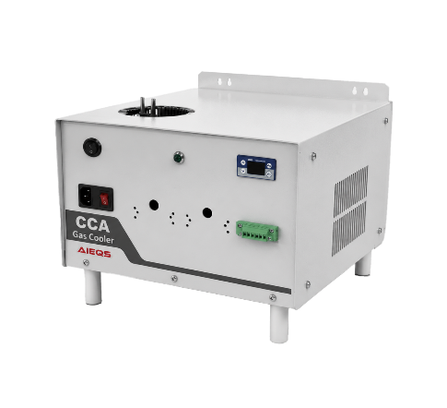 |  |  |  | Compressor Gas Cooler  2026  NEW
 |  |  |  | CCA 992C
انتخاب کد مورد نظر: |  |  |  |  |  |  |  | Select Required Code:
CCA  992C | 0  1 | بدون مبدل  با مبدل | 0 (None)  G (Duran Glass)  S (SS316)  P (PTFE / PVDF) | جنس مبدل | 1  2  3  4 | تعداد مبدل | 1=150  2=250 | فلوی گاز Nl/hr | 0 (None)  1 (SR25 Pump)  2 (Auto Trap) | Auto Trap / SR25  به ازای هر مبدل حرارتی

ویژگیها: |  |  |  | Highlights:
- تنظیم دمای نقطه شبنم خروجی از +2 °C تا +7 °C  - پایداری دمای تنظیم شده خروجی گاز ±0.1 °C  - دو خروجی رله آلارم اعلام وضعیت آماده بکار  - PID کنترلر الکترونیکی با نمایشگر دیجیتالی دما  - دمای محیط کار 0….+50 °C  - زمان راه اندازی کمتر 15 دقیقه و پایداری 2 ساعت  - بدنه دیواری و راک استاندارد 19 اینچ  - مدل ویژه جهت دمای نقطه شبنم گاز خروجی -40°C |  |  |  |  |  | - Gas outlet temperature from gas cooler adjusting from +2 °C to +7 °C  - Gas outlet temperature stability ±0.1 °C  - 2 relays for Status Alarm Ready to work signal  - With PID electronic controller with digital display  - Working Ambient Temperature: 0….+50 °C  - Start-up time < 15 min and stable 2 hours in constant process condition  - Wall mount Enclosure and Standard 19” Rack mount  - Special Version for -40°C gas outlet dew point temperature
کاربردها: |  |  |  |  |  | Product Information:
نصب در سیستم های آنالایزر برخط گاز  در کلیه صنایع  کلیه سیستمهای آنالایزر بر خط گاز  خشک کن هوای ابزار دقیق در نقطه مصرف
  Sample outlet dew point | Range of adjustment: +2 °C..... +7 °C, factory setting: +5 °C
  Dew point stability | at const. conditions: < ±0,1°C
  Sample inlet temperature | max. +180°C
  Ambient temperature | 0 to +50°C
  Storage temperature | -20 to +70°C
  Total cooling capacity | Min 40W at 10°C … 50°C ambient temperature
  Ready for working | < 15 min (stability time at constant process condition > 120 mins)
  Power consumption | max. 200VA (startup current at 230V=2,5A; at 120V=4,5A)
  Main power connection | 240V/120V, 50Hz/60Hz (a): -15%/+10%
  Electrical connections | terminals: 6-12mm, cable gland: 2xPG11
  Status alarm | 1 free configurable status alarm with 2 potential free change-over contacts, alarm point:  < 2°C and > 8°C contact rating 250VAC, 2A; 500 VA; 50W
  System of protection | IP20
  Case color | white
  Method of mounting | wall mounting / 19” Rackmount
  Dimensions Weight | 360 x 270 x 350 mm (WxHxD) 12kg (version: 230V/115V)  483 x 270 x 350 mm (WxHxD) 17,5kg (version: 230V/115V) 19” Rackmount
  Signal Output | Modbus 485 to AIEQS HMI and customer HMI
Applications:
- Suitable to install in gas analyzer system of Cement, Steel plants
- For all gas analyzer system
- Instrument air drier at the using point
Technical Information for CCA
2026
NEW
-⁵ | -⁴ |  | -³ |  |  |  | -² |  |  | -¹ | How to Order | 1
Note 5: Select with or without pumpSR25 or auto trap | Note 4: Choose Gas flow per each heat exchanger |  | Note 3: Select the number of heat exchanger |  |  |  | Note 2: Choose Material of heat exchanger |  |  | Note 1: Select with or without heat exchanger | CCA 992C | 1
0 (None)  1 (SR25 Pump)  2 (Auto Trap) | 1=150 Nl/hr  2=250 Nl/hr |  | 1/2 (Note 6) |  |  |  | 0 (None)  G (Duran Glass)  S (SS316)  P (PTFE / PVDF) |  |  | 0 (without heat exchanger)  1 (with heat exchanger) | CCA 992C | 1
Examples:  992C1S211: CCA 992C gas cooler with 2×150 Nl/hr SS heat exchanger with SR 25 per each ÷exchanger  992C00120: CCA 992C gas cooler without heat exchanger without drain option prepared for one 250 Nl.hr heat exchanger  Note 6: max two heat exchangers of 150 Nl/hr and only one heat exchangers of 250 Nl/hr is install in this type gas cooler. |  |  |  |  |  |  |  |  |  |  | CCA 992C | 1
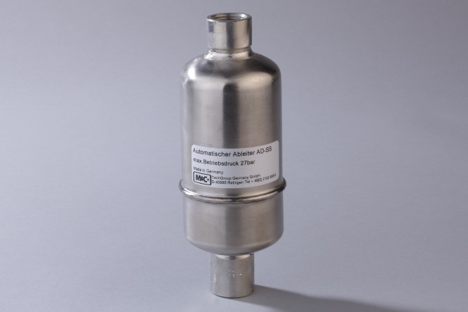 |  |  |  |  | 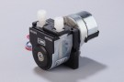 |  |  |  |  |  | Condensate Removal Options | 2
Automatic condensate trap |  |  |  |  | Peristaltic pump SR25.2
1509K3000 (optional)  Automatic condensate trap with float type AD-SS. Condensate-IN: 1/2"NPTi, Condensate-OUT: 1/2"NPTi. Material: stainl. steel. |  |  |  |  | 1501P1300 (Optional)  Peristaltic pump SR25.2, for panel mounting Wall thickness max.1,5mm capacity of 0,30 l/hr, pressure range 200mbar up to 2,2bar abs. Material: Novopren, PVDF, connections for tube DN 4/6mm, power: 115/230V, 50/60Hz.
توجه : مشخصات فنی دستگاه با توجه به نیاز مشتری با هر ابعاد بدنه و توان برودتی و هر تعداد مبدل در زمان سفارش مورد قبول است. |  |  |  |  | Other Technical Specification and other Enclosure Dimensions acceptable on order.
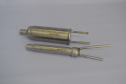  SS |  | 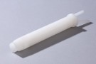  PV |  |  |  |  |  |  | 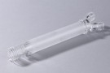  GL |  | CCA Part No Technical Information | 3
- Jet-stream heat exchanger for cooler  - Material: ss316  - Stagnant space approx40-100ml  - Sample gas pressure abs. Max. 6barg  - Made in IRAN |  | - Jet-stream heat exchanger for cooler  - Material: PVDF  - Stagnant space approx40-100ml  - Sample gas pressure abs. Max. 3bar  - Made in GERMANY |  |  |  |  |  |  | - Jet-stream heat exchanger for cooler  - Material: Duran glass  - Stagnant space approx40-100ml  - Sample gas pressure abs. Max. 2bar  - Made in GERMANY
  9910C1250 | 1 Stream | 250Nl/h
  9910C2150 | 2 Stream | 150Nl/h
  1593K0170 | 1 Stream | 250Nl/h
  1597K0110 | 2 Stream | 150Nl/h
  1593K0140 | 1 Stream | 250Nl/h
  1597K0100 | 2 Stream | 150Nl/h

 | Dimensions | 4
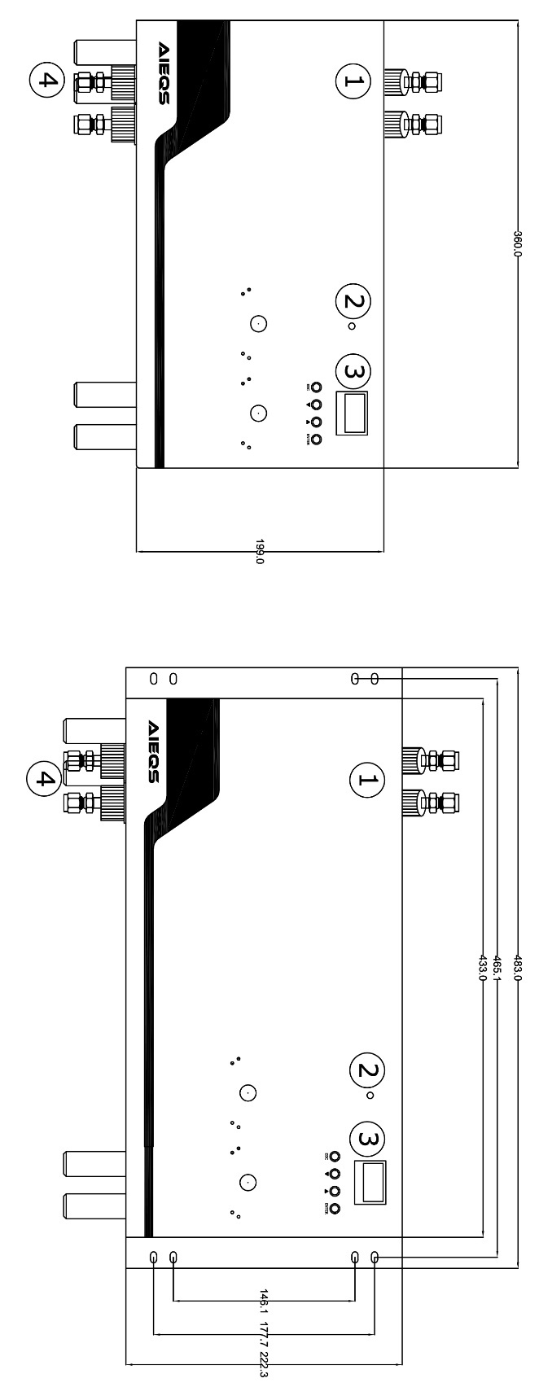
FRONT VIEW
(1) | Sample Gas Inlet / Outlet | ورودی و خروجی گاز Sample | (1)
(2) | Status LED (compressor works OK) | LED نشانگر کارکرد کمپرسور | (2)
(3) | PID Controller Digital Display | PID کنترلر و نمایشگر دما | (3)
(4) | Condensate Outlet | خروجی آب از مبدل | (4)

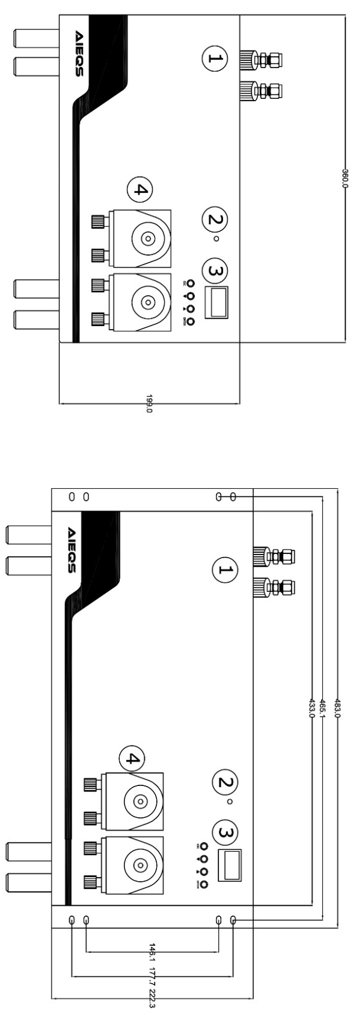
FRONT VIEW
(1) | Sample Gas Inlet / Outlet | ورودی و خروجی گاز Sample | (1)
(2) | Status LED (compressor works OK) | LED نشانگر کارکرد کمپرسور | (2)
(3) | PID Controller Digital Display | PID کنترلر و نمایشگر دما | (3)
(4) | SR25.2 Peristaltic Pumps | پمپ های SR25.2 جهت مکش آب از خروجی مبدل | (4)
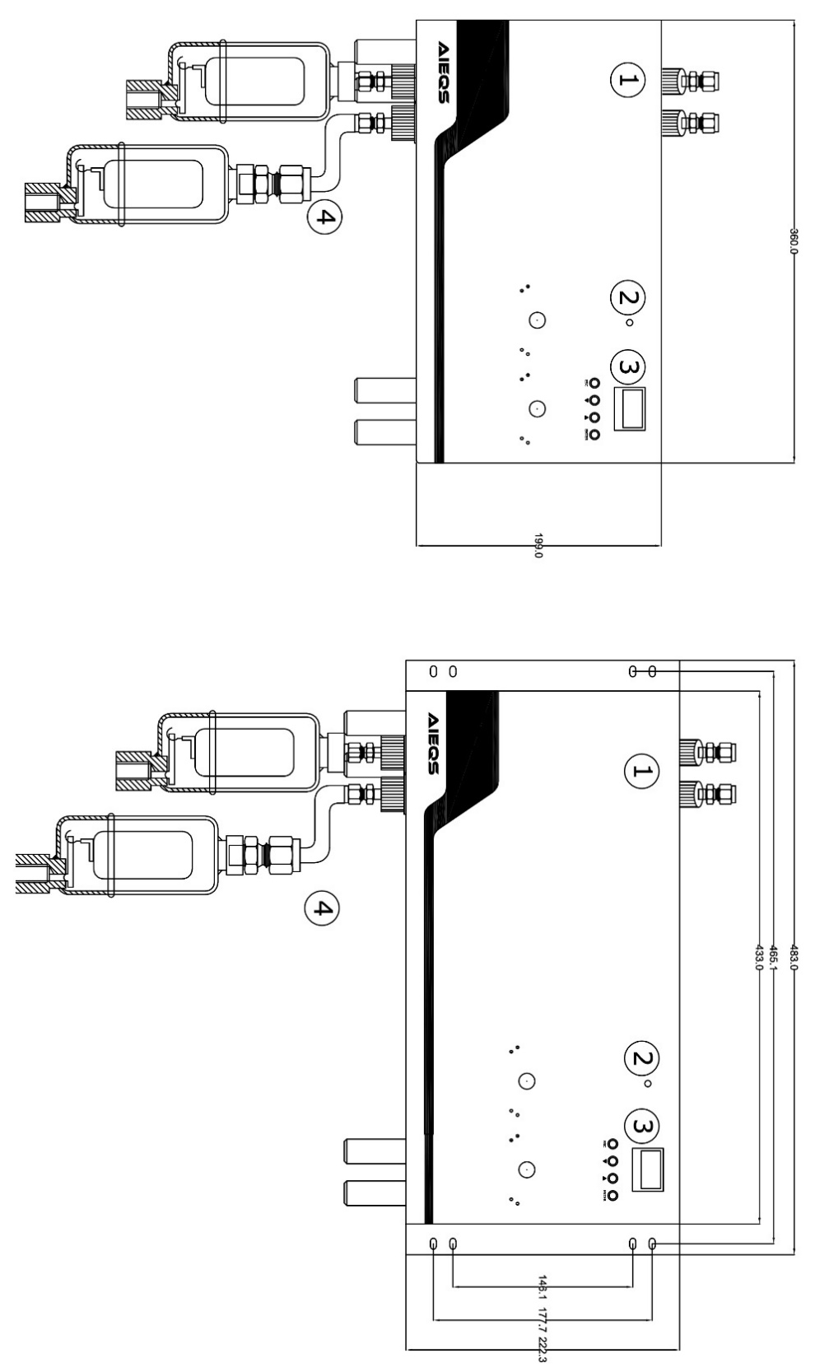
FRONT VIEW
(1) | Sample Gas Inlet / Outlet | ورودی و خروجی گاز Sample | (1)
(2) | Status LED (compressor works OK) | LED نشانگر کارکرد کمپرسور | (2)
(3) | PID Controller Digital Display | PID کنترلر و نمایشگر دما | (3)
(4) | Auto Condensate Trap Outlet | اتو ترپ برای خروجی آب از مبدل | (4)

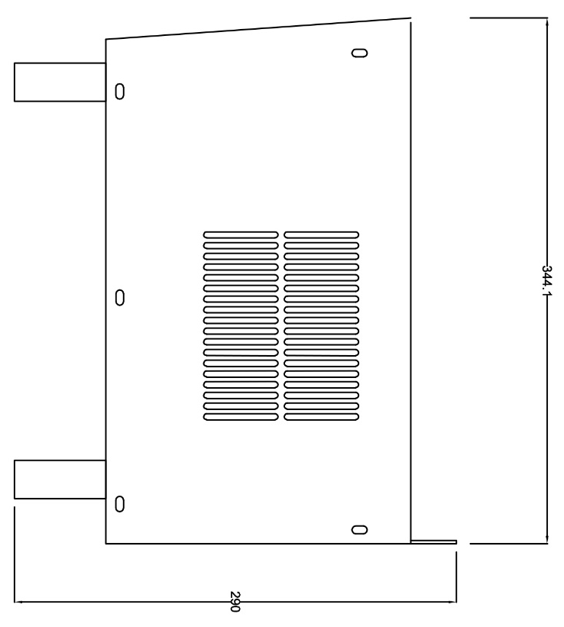
SIDE VIEW

